**Government Polytechnic, Pune-16**

**(An Autonomous Institute of Government of Maharashtra)**



**A**

**Micro project Report**

**On**

**“Webpage Development for creating a tip calculator”**

**SUBMITTED BY:**

|  |  |
| --- | --- |
| Student Name : | **Shivani Zele** |
| Enrollment Number : | **1907069** |

**Under the Guidance of**

**Smt. Mrunal Kokate**

**DEPARTMENT OF INFORMATION TECHNOLOGY**

**(Academic Year: 2021-22)**

**Government Polytechnic, Pune-16**

**(An Autonomous Institute of Government of Maharashtra)**

**Department Information Technology**



**CERTIFICATE**

 This is to certify that  **Shivani Zele** with Enrollment No. **1907069** of Second Year Diploma in Information Technology has successfully completed the Micro project titled “Webpage Application for creating a Tip calculator” as part of his diploma curriculum of Subject :-**Web Development using JavaScript**  in academic year 2021-22.

              Guide                                HOD                             Principal

(Smt. M.U Kokate) (Smt. M.U Kokate)          (Dr. V.S Bandal)

**ACKNOWLEDGMENT**

It is my proud privilege and duty to acknowledge the kind of help and guidance received from several people in the preparation of this report. It would not have been possible to prepare this report in this form without their valuable help, cooperation and guidance.

First and for most I express my sincere gratitude to my Guide, **Mrs. M. U. Kokate** for guiding me in investigations of this seminar and in carrying out experimental work. My sincere thanks to **Mrs. M. U. Kokate** Head of the department, Information Technology, Government Polytechnic Pune for her valuable suggestions and guidance throughout the preparation of this report.

Last but not the least I wish to thank my parents for financing my studies and helping me throughout my life for achieving perfection and excellence. Their personal help in making this report and seminar worth presentation is gratefully acknowledged.

**Student name : Shivani Zele**

**Enrollment no : 1907069**.

**(Second Year IT)**

**________________________________________________________**

**Introduction**:

The following project has been developed using The Javascript, Html and CSS language . In this microproject we have created a program for “**Webpage Development for creating a tip calculator**

This project has been developed by Javascript programming language by using Html and CSS . we can use Visual studio code, notepad ++, any other notepad for this project. various concepts of Javascript we are used to give this project the required perfection.

In this project we use Visual Studio code software . By using this project we can calculate a tip Amount of an Person .We can calculate Bill Amount , Tip Amount, and Amount for a each person working in hotel/Restaurant.

* **Problem statement** :

“**Web Page Development for creating a Tip Calculator**” . By using this project we can calculate a tip Amount of an Person .We can calculate Bill Amount , Tip Amount, and Amount for a each person working in hotel/Restaurant.

**SYSTEM DESIGN**

**Front end: HTML, CSS, JavaScript**

1. HTML: HTML is used to create and save web document. E.g. Notepad/Notepad++
2. CSS: (Cascading Style Sheets) Create attractive Layout
3. JavaScript: it is a programming language, commonly use with web browsers.
4. **Software Requirement (any one) :**“Development of Tip calculator using JavaScript”.

* Notepad/Visual Studio Code
* Notepad++

--------------------------------------------------------------------------------------------------------------

**IMPLEMENTATION**

**(Coding pages can be attached here)**

**Tipcalulator.html**

<html>

<head>

<style>

body {

font-family: 'Raleway', sans-serif;

background-image: url("hotel.png");

background-repeat: no-repeat;

background-size: cover;

}

.container {

width: 350px;

height: 500px;

background-color: #fff;

position: absolute;

left: 50%;

top: 50%;

transform: translateX(-50%) translateY(-50%);

border-radius: 20px;

}

h1 {

position: absolute;

left: 50%;

top: -60px;

width: 300px;

transform: translateX(-50%);

background-color: #dfbb1938;

color: #fff;

font-weight: 100;

border-radius: 10px;

border-radius: 10px;

font-size: 18px;

text-align: center;

padding: 10px;

}

.wrapper {

padding: 20px;

padding-bottom: 1px;

}

input,

select {

width: 80%;

border: none;

border-bottom: 1px solid #0074D9;

padding: 10px;

}

input:focus,

select:focus {

border: 1px solid #0074D9;

outline: none;

}

select {

width: 88% !important;

}

button {

margin: 20px auto;

margin-left: 90px;

width: 120px;

height: 50px;

background-color: #1c1d1d;

color: #fff;

font-size: 16px;

border: none;

border-radius: 5px;

border-radius: 15px;

}

.tip {

text-align: center;

font-size: 14px;

display: none;

}

</style>

</head>

<body>

<div class="container">

<h1>TIP CALCULATOR</h1>

<div class="wrapper">

<p>Bill Amount*</p>

<input type="text" id="amount" placeholder="Amount to be paid"> Rs.

<p>Rate*</p>

<select id="services">

<option selected disabled hidden>Select</option>

<option value="0.02">2%</option>

</select>

<p>Total number of persons*</p>

<input type="text" id="persons" placeholder="Number of people sharing the bill">

<button id="calculate">Calculate</button>

</div>

<div class="tip">

<p>Bill Amount: <span id="total-bill"></span> Rs.</p>

<p>Tip Amount: <span id="tip-amount"></span> Rs.</p>

<p>Amount for each Person : <span id="total"></span> Rs.</p>

</div>

</div>

<script>

//the function called when Calculate button is clicked.

window.onload = () => {

/*calling a function calculateTip which

will calculate the tip for the bill.*/

document.querySelector('#calculate').onclick =

calculateTip;

}

function calculateTip() {

/*assing values of ID : amount, person and

service to variables for further calculations.*/

let amount = document.querySelector('#amount').value;

let persons = document.querySelector('#persons').value;

let service = document.querySelector('#services').value;

document.querySelector('#total-bill').innerHTML = amount;

console.log(service);

/*if statement will work when user

presses calculate without entering values. */

//so will display an alert box and return.

if (amount === '' && service === 'Select') {

alert("Please enter valid values");

return;

}

let total = (amount * service) / persons;

total = total.toFixed(2);

let tipAmount = (amount * service);

//finally displaying the tip value

document.querySelector('.tip').style.display = 'block';

document.querySelector('#total').innerHTML = total;

document.querySelector('#tip-amount').innerHTML = tipAmount;

}

</script>

</body>

</html>

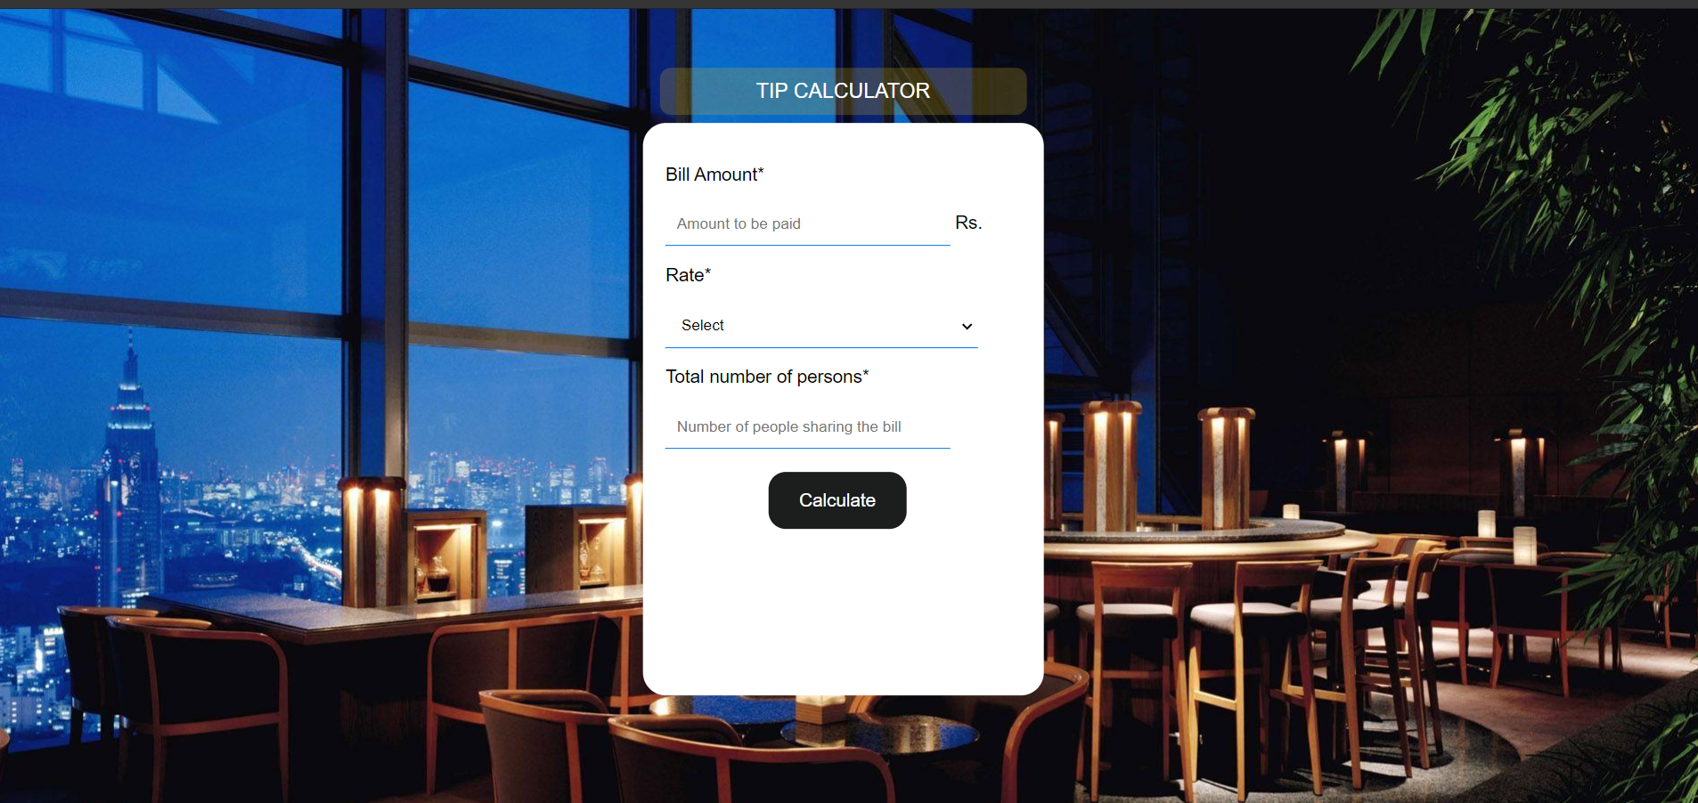**Output :**

* 1. This is a front page. We have Enter all the values properly.

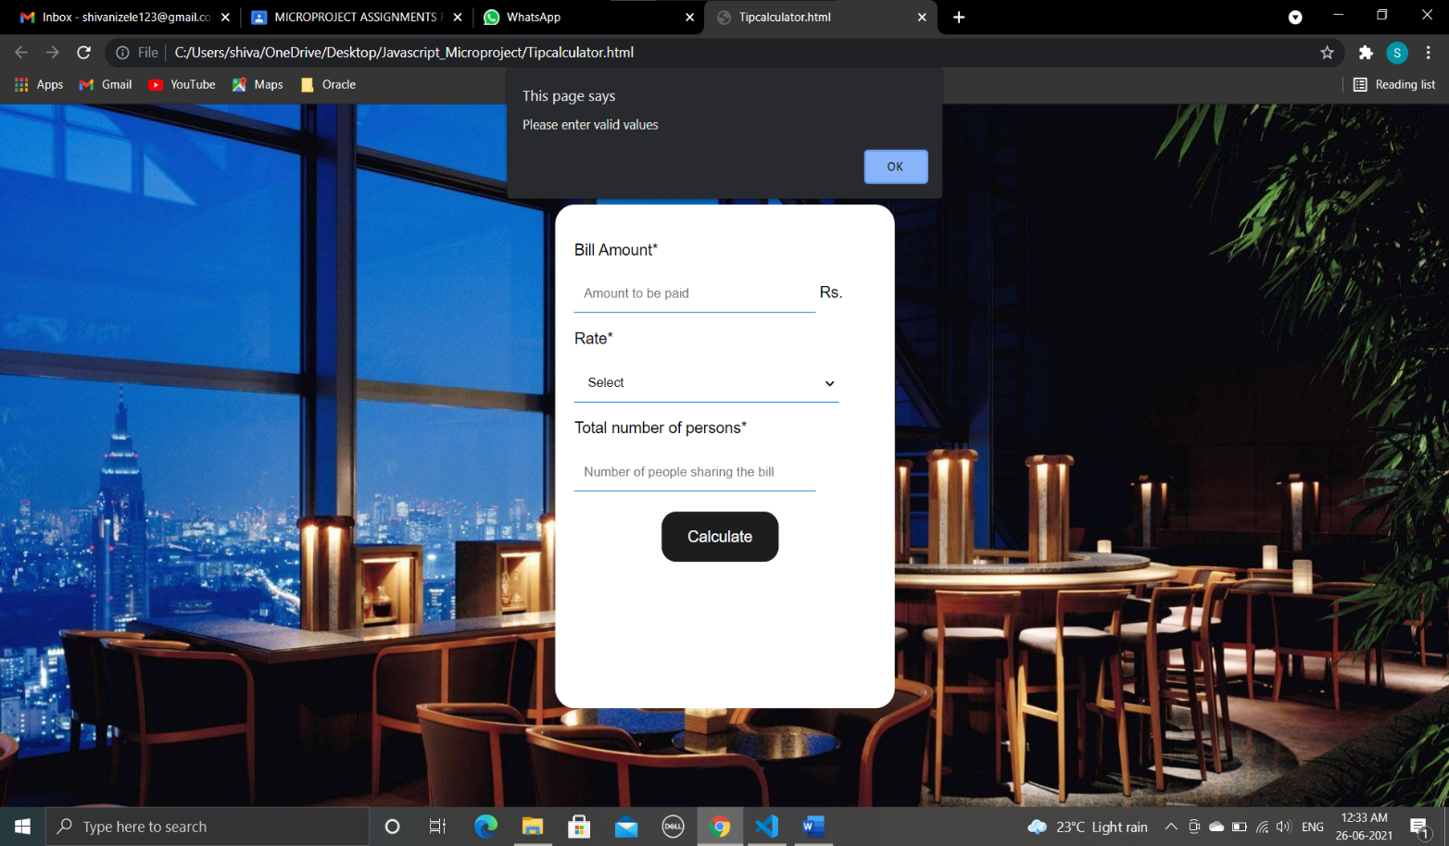

* 1. If you are trying to calculate without entering any value then the please enter valid values this message will be displayed.

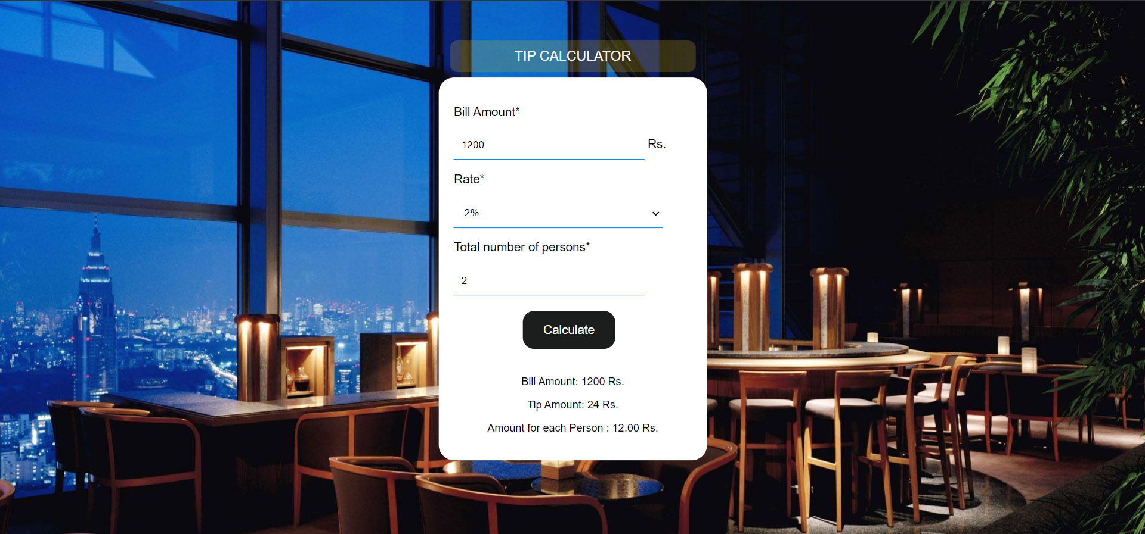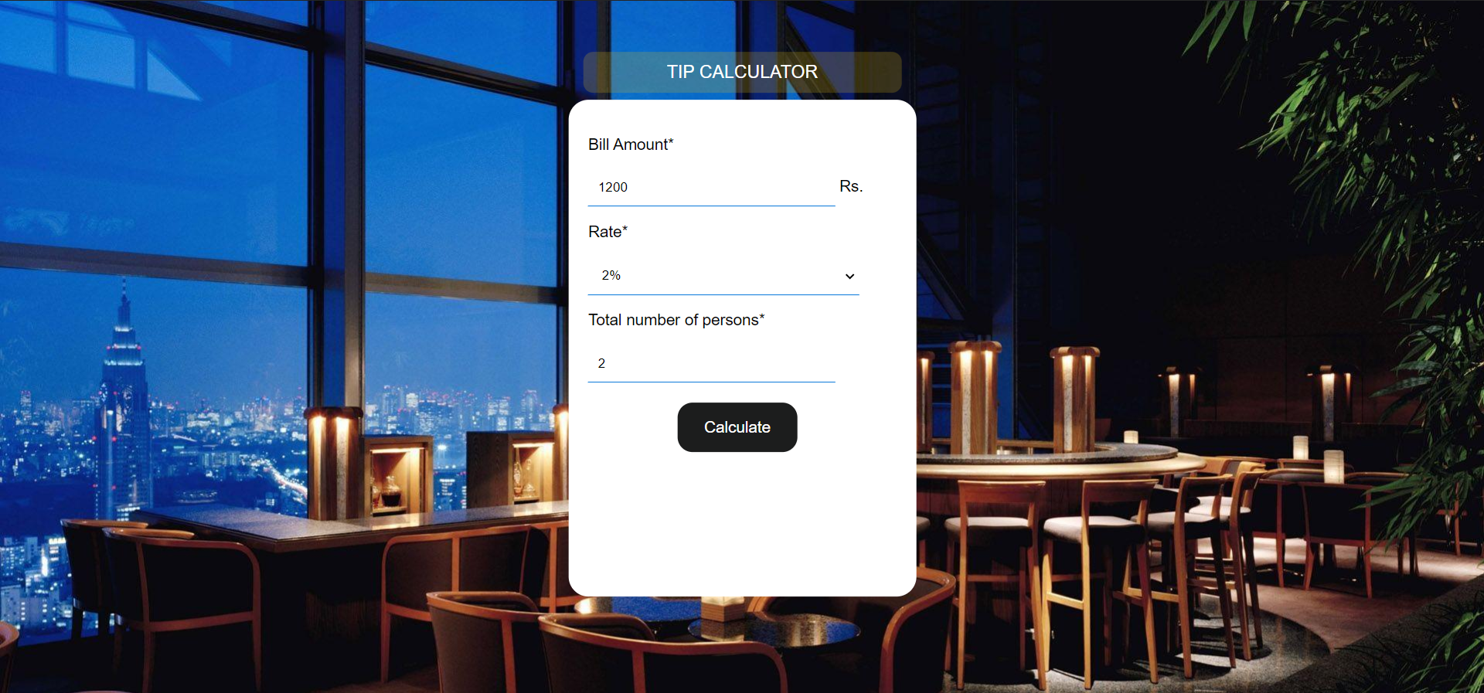

* 1. After clicking on submit button we can find Bill Amount , Tip Amount and Tip Amount for each person.

**APPLICATIONS**

Problem statement :“ **Webpage Development for creating a tip calculator**” . By using this project we can calculate a tip Amount of an Person .We can calculate Bill Amount , Tip Amount, and Amount for a each person working in hotel/Restaurant.

**Outcome achieved :**

* 1. Working towards achieving the desired outcome , finding out ways to achieve the outcome in the simplest and fastest possible.
  2. Putting up various concepts together, and making effective concepts.
  3. Achieving the desired outcome using the shortest way.
  4. Logic building.

|  |
| --- |
| CONCLSION: |
| Thus we have used various concepts of JavaScript to create a micro-project on topic “Webpage Application for creating a tip calculator”. |

**Sign.**